**CHAPTER 1**

**INTRODUCTION**

**1.1 BASICS OF HEAT TRANSFER:**

Heat Transfer deals with the transmission of energy from one region to another as a result of temperature difference. The transfer of energy as heat is always from the higher-temperature medium to the lower-temperature one. Heat transfer stops when the two mediums reach the same temperature. Heat transfer equipment’s such as heat exchangers, boilers, condensers, radiators, heaters, furnaces, refrigerators, and solar collectors are designed primarily on the basis of heat transfer analysis. Heat transfer per unit time is called Rate of Heat Transfer. Denoted by Q (SI unit- Joule/sec).

**1.1.1 ENTHALPY:**

In the analysis of systems that involve fluid flow, we frequently encounter the combination of properties *u* and *Pv*. The combination is defined as enthalpy(*h* = *u* + *Pv*). The term *Pv* represents the flow energy of the fluid (also called the flow work).

**1.1.2 SPECIFIC HEAT:**

The energy required to raise the temperature of a unit mass of a substance by one degree. The specific heats of a substance, in general, depend on two independent properties such as temperature and pressure.

Two kinds of specific heats:

* Specific heat at constant volume Cv-

It is the energy required to raise the temperature of unit mass of the substance by one degree at a constant volume.

* Specific heat at constant pressure Cp **-**

It is the energy required to raise the temperature of unit mass of the substance by one degree at a constant pressure.

**1.2 ENERGY BALANCE FOR STEADY-FLOW SYSTEMS:**

In the heat exchanger analysis, steady state is assumed. Under steady conditions, the net rate of energy transfer to a fluid in a control volume is equal to the rate of increase in the energy of the fluid stream flowing through the control volume.

Q = m∆h = mCp∆T … (1.1)

A large number of engineering devices such as water heaters and car radiators involve mass flow in and out of a system, and are modeled as control volumes*.*

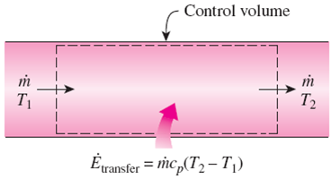

Figure 1.1: Transfer of Energy across Control Volume

**1.3 MODES OF HEAT TRANSFER:**

Heat can be transferred in three modes

* Conduction.
* Convection.
* Radiation.

**1.4 CONDUCTION:**

The transfer of energy from the more energetic particles of a substance to the adjacent less energetic ones as a result of interactions between the particles is conduction. In gases and liquids, conduction is due to the collisions and diffusion of the molecules during their random motion. In solids, it is due to the combination of vibrations of the molecules in a lattice and the energy transport by free electrons.

**1.4.1 FOURIER LAW OF CONDUCTION:**

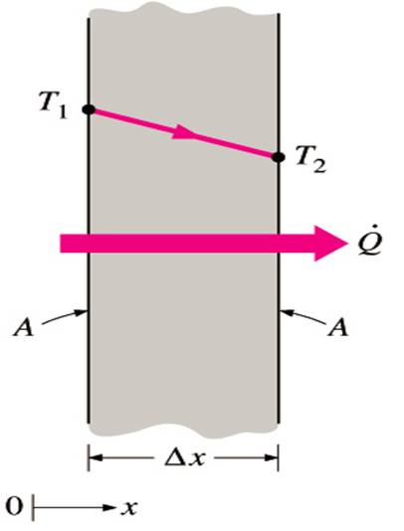 “The rate of heat conduction through a plane layer is proportional to the temperature difference across the layer and the heat transfer area and inversely proportional to the thickness of the layer.”

$Q=K A \frac{T_{1}-T_{2}}{∆x}$…(1.2)

Figure 1.2: Heat Conduction through a Large Plane Wall of Thickness Δx and Area A

**1.4.2 THERMAL CONDUCTIVITY (K):**

It is the rate of heat transfer through a unit thickness of the material per unit area per unit temperature difference. The thermal conductivity [1] of a material is a measure of the ability of the material to conduct heat.

A high value for thermal conductivity indicates that the material is a good heat conductor and a low value indicates that the material is a poor heat conductor or insulator.

|  |  |
| --- | --- |
| **Material** | **K(W/m ᵒC)** |
| Diamond | 2300 |
| Silver | 429 |
| Copper | 401 |
| Gold | 317 |
| Aluminium | 237 |
| Iron | 80.2 |
| Mercury(Liquid) | 8.54 |
| Glass | 0.78 |
| Brick | 0.72 |
| Water(Liquid) | 0.607 |
| Human Skin | 0.37 |
| Wood(oak) | 0.17 |

Table 1.1: Thermal Conductivity of some Materials at Room Temperature

**1.5 CONVECTION:**

The mode of energy transfer between a solid surface and the adjacent liquid or gas that is in motion is convection. It involves the combined effects of conduction and fluid motion. The faster the fluid motion, the greater the convection heat transfer. In the absence of any bulk fluid motion, heat transfer between a solid surface and the adjacent fluid is by pure conduction.

There are mainly two types of convection

* Natural or Free Convection.
* Forced Convection.

**1.5.1 NATURAL CONVECTION:**

If the fluid motion is caused by buoyancy forces that are induced by density differences due to the variation of temperature in the fluid, it is called natural convection.

**1.5.2 FORCED CONVECTION:**

If the fluid is forced to flow over the surface by external means such as a fan, pump, or the wind, it is called forced convection.

Heat transfer processes that involve change of phase of a fluid are also considered to be convection because of the fluid motion induced during the process, such as the rise of the vapor bubbles during boiling or the fall of the liquid droplets during condensation.

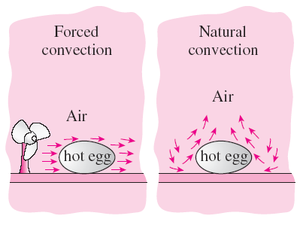

Figure 1.3: The Cooling of a Boiled Egg by Forced and Natural Convection

**1.5.3 NEWTON'S LAW OF COOLING:**

It states that "When a fluid at a temperature is in contact with solid surface at different temperature, the heat flux (q) from the solid surface to fluid is proportional to temperature difference between these two."

Q = hA∆T … (1.3)

The constant of proportionality (h) is called Convection heat transfer co-efficient.

**1.6 RADIATION:**

The energy emitted by matter in the form of electromagnetic waves (or photons) as a result of the changes in the electronic configurations of the atoms or molecules. Unlike conduction and convection, the transfer of heat by radiation [2] does not require the presence of an intervening medium.

**NOTE:** In the present analysis effect of radiation is completely neglected as the contribution towards heat loss is less and insulation from surroundings is assumed.

**1.7 INTRODUCTION TO FINITE ELEMENT METHODS**

The finiteelementmethod (FEM) [3] is a numerical method for solving problems of engineering and mathematical physics. It is also referred to as finiteelementanalysis (FEA). Typical problem areas of interest include structural analysis, heat transfer, fluid flow etc.

The finite element method formulation of the problem results in a system of algebraic equations. The method yields approximate values of the unknowns at discrete number of points over the domain.

To solve the problem, it subdivides a large problem into smaller, simpler parts that are called finite elements. The simple equations that model these finite elements are then assembled into a larger system of equations that models the entire problem.

**1.8 STEPS IN FINITE ELEMENT METHODS**

1. **DISCRETISATION OF CONTINUUM:** The first step in the method is to divide the given continuum into smaller regions of finite dimensions called as ‘‘finite elements’’. The original continuum is then considered as an assemblage of these elements connected at a finite number of joints called as “nodes” or “nodal points”.
2. **SELECTION OF APPROXMATING FUNCTION:** Approximating functions are also known as an interpolation models. Interpolation model is the starting point of the analysis. A convenient way to express it is by polynomial expressions.
3. **FORMATION OF ELEMENT STIFFNESS MATRIX:** After continuum is discretized with desired element shapes, the individual element stiffness matrix is formulated. Basically it is a minimization procedure whatever may be the approach adopted.
4. **FORMATION OF OVERALL STIFFNESS MATRIX:** After the element stiffness matrices in global coordinates are formed, they are assembled to form the overall stiffness matrix. The assembly is done through the nodes which are common to adjacent elements. The overall stiffness matrix is also known as global stiffness matrix.
5. **FORMATION OF ELEMENT LOADING MATRIX:** The loading inside an element is transferred at the nodal points and consistent element matrix is formed.
6. **FORMATION OF OVERALL LOADING MATRIX:** Like the overall stiffness matrix, the element loading matrices are assembled to form the overall loading matrix. The matrix has one column per loading case and it is either a column vector or a rectangular matrix depending on the number of loading cases.
7. **FORMATION OF THE OVERALL EQUILIBRIUM EQUATION:** Overall equilibrium is the systematic arrangement of the overall stiffness matrix, overall load vector and overall displacement vector to get set of simultaneous equations.

[K]{Q}= {F} … (1.4)

Where, [K] is an overall or global stiffness matrix (square matrix)

{Q} is an overall or global displacement vector (column matrix)

{F} is an overall or global force vector (column matrix)

1. **BOUNDARY CONDITIONS:** The solution cannot be obtained unless the support conditions are included in the stiffness matrix. This is because, if all nodes are included in the displacement vector, the stiffness matrix becomes singular can cannot be solved if the structure is not supported amply and it cannot resist the applied loads.
2. **SOLUTION:** After incorporation of boundary conditions, the required unknowns are calculated.

**1.9 ADVANTAGES OF FEM:**

1. The physical properties, which are intractable and complex for any closed bound solution, can be analysed by this method.
2. It can take care of any geometry.
3. It can take care of any boundary conditions.
4. It can take care of any type of loading conditions.
5. Material anisotropy and non-homogeneity can be catered without much difficulty.
6. Easy to computer program the process.

**1.10 DISADVANTAGES OF FEM:**

1. Computational time involved in the solution of the problem is high.
2. For fluid dynamics problems some other methods if analysis may prove more efficient.
3. Experience and judgment are needed in order to construct a good finite element model.
4. Susceptible to user-introduced errors.
5. Mistakes by users can be fatal.

**1.11 FINITE ELEMENT CONCEPTS:**

**1.11.1 SHAPE FUNCTIONS:**

The shape function is the function which interpolates the solution between the discrete values obtained at the mesh nodes. Therefore, appropriate functions have to be used and, as already mentioned, low order polynomials are typically chosen as shape functions. In this work linear shape functions are used.

**1.11.2 WEIGHTED RESIDUAL METHODS:**

Weighted average methods are also often called "[Rayleigh-Ritz Methods](https://en.wikiversity.org/w/index.php?title=Rayleigh-Ritz_Methods&action=edit&redlink=1)". The idea is to satisfy the differential equation in an average sense by converting it into an integral equation. The differential equation is multiplied by a weighting function and then averaged over the domain.

1. **SUB-DOMAIN COLLOCATION:**

In the subdomain collocation method, we divide the physical domain into a number of non-overlapping sub-domains. Number of sub-domains n is taken as equal to the number of unknown coefficients in the approximating function. Now, each weight function is selected as unity over a specific subdomain and set equal to zero over other the other parts.

1. **GALERKIN METHOD:**

In the Galerkin’s method, each weight function is selected as the shape functions. For higher accuracy of results, higher order functions have to be assumed.

**SUMMARY**

1. The heat transfer takes place only when there is a temperature difference between the mediums. Only when steady conditions is assumed, the net rate of energy transfer to a fluid in a control volume is equal to the rate of increase in the energy of the fluid stream flowing through the control volume.
2. For any heat transfer analysis, the contributions of basic terminologies like Enthalpy, specific heats are very crucial.
3. Finite element analysis always divides any problem into a number of smaller, simplified parts and the solution obtained is assembled into the given final problem. Any complicated mathematical problems, the problems to be computer programmed, can easily be done by Finite Element Analysis.
4. Finite Element Analysis is utilized in many engineering applications like heat transfer, Structural analysis, fluid flow etc.

**CHAPTER 2**

**SOFTWARE REQUIREMENT (MATLAB)**

**2.1 ABOUT MATLAB:**

The name MATLAB stands for Matrix Laboratory. MATLAB was written originally to provide easy access to matrix software developed by the LINPACK (linear system package) and EISPACK (Eigen system package) projects.

MATLAB is a high-performance language for technical computing. It integrates computation, visualization, and programming environment. Furthermore, MATLAB is a modern programming language environment: it has sophisticated data structures, contains built-in editing and debugging tools, and supports object-oriented programming. These factors make MATLAB an excellent tool for teaching and research.

**2.2 HISTORY:**

* MATLAB was developed primarily by Cleve Moler in the 1970’s
* It was derived from FORTRAN subroutines LINPACK and EISPACK, linear and Eigen value systems.
* It was developed primarily as an interactive system to access LINPACK and EISPACK.
* It gained its popularity through word of mouth, because it was not oﬃcially distributed.
* It was rewritten in C in the 1980’s with more functionality, which includes plotting routines.
* The MathWorks Inc. was created (1984) to market and continue development of MATLAB.

**2.3 STARTING MATLAB:**

After logging into your account, you can enter MATLAB by double-clicking on the MATLAB shortcut icon on your Windows desktop. When you start MATLAB, a special window called the MATLAB desktop appears. The desktop is a window that contains other windows. The major tools within or accessible from the desktop are:

* The Command Window
* The Command History
* The Workspace
* The Current Directory

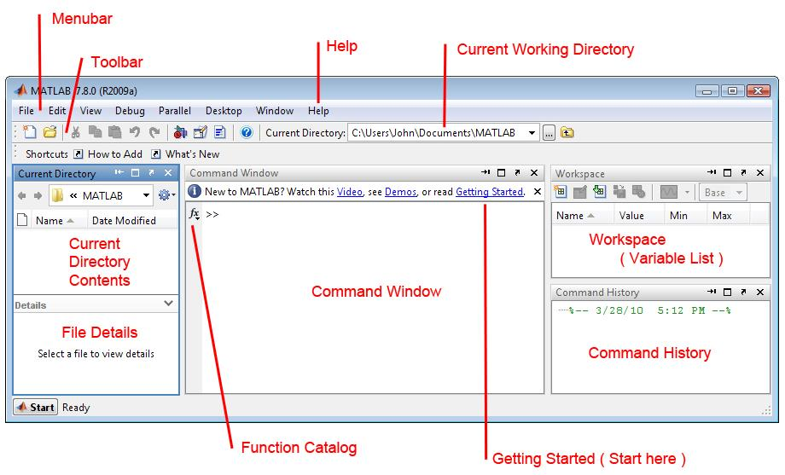

Figure 2.1: The Graphical Interface to the MATLAB Workspace

When MATLAB is started for the ﬁrst time, the screen looks like the one that shown in the Figure 2.1.This illustration also shows the default conﬁguration of the MATLAB desktop. You can customize the arrangement of tools and documents to suit your needs. We are now faced with the MATLAB desktop on our computer, which contains the prompt (>>) in the Command Window. Usually, there are 2 types of prompt:

>> for full version EDU

>> for educational version

**2.4 PROGRAMMING USING MATLAB:**

MATLAB is also a programming language. Like other computer programming languages, MATLAB [4] has some decision making structures for control of command execution. These decision making or control ﬂow structures include for loops, while loops, and if-else-end constructions.

Control ﬂow structures are often used in script M-ﬁles and function M-ﬁles. By creating a ﬁle with the extension .m, we can easily write and run programs. We do not need to compile the program since MATLAB is an interpretative (not compiled) language. MATLAB has thousands of functions, and you can add your own using m-ﬁles.

**2.5 CONTROL FLOW:**

MATLAB provides several tools that can be used to control the ﬂow of a program (script or function). In a simple program as shown in the previous Chapter, the commands are executed one after the other. Here we introduce the ﬂow control structure that make possible to skip commands or to execute speciﬁc group of commands. MATLAB has four control ﬂow structures: the if statement, the for loop, the while loop, and the switch statement.

**2.5.1 The ‘‘if...end’’ structure:**

MATLAB supports the variants of “if” construct.

* if ... end
* if ... else ... end
* if ... elseif ... else ... end.

**2.5.2 The ‘‘for...end’’ loop:**

In the for ... end loop, the execution of a command is repeated at a ﬁxed and predetermined number of times. The syntax is

for variable = expression

Statements;

end.

**2.5.3 The ‘‘while...end’’ loop:**

This loop is used when the number of passes is not speciﬁed. The looping continues until a stated condition is satisﬁed. The while loop has the form:

while expression

Statements;

end.

**2.6 STRENGTHS:**

* MATLAB may behave as a calculator or as a programming language.
* MATLAB combine nicely calculation and graphic plotting.
* MATLAB is relatively easy to learn.
* MATLAB is interpreted (not compiled), errors are easy to ﬁx.
* MATLAB is optimized to be relatively fast when performing matrix operations.
* MATLAB does have some object-oriented elements.

**2.7 WEAKNESSES:**

* MATLAB is not a general purpose programming language such as C, C++, or FORTRAN.
* MATLAB is designed for scientiﬁc computing, and is not well suitable for other applications.
* MATLAB is an interpreted language, slower than a compiled language such as C++.
* MATLAB commands are speciﬁc for MATLAB usage. Most of them do not have a direct equivalent with other programming language commands.

**CHAPTER 3**

**LITERATURE SURVEY**

Due to many engineering applications of the heat exchangers, intensive research has been carried out for the last several decades. Many research efforts addressed the enhancement of heat transfer between two or more fluids with different temperatures through special flow configuration and shape of the heat exchanger contact surface area.

Following research works greatly contributed to the analysis done in the project as they gave the basics and methodology to conduct the analysis:

Sekulic and Shah (1995) have presented in detail a review on thermal design theory of three-fluid heat exchangers [5], where they have allowed the third fluid temperature to vary according to the prevailing thermal communications while neglecting interaction with the ambient.

Recently, Shrivastava and Ameel (2004) [6] have developed a mathematical model based on Sekulic and Shah (1995) review for three-ﬂuid heat exchanger. In these studies Shrivastava and Ameel, (2004), six non-dimensional design parameters were identified and their effect on the temperature distributions of the different fluid streams were presented. Several effectiveness definitions have been proposed to assess the performance of three-ﬂuid heat exchangers.

The report "Finite Element Method for Heat Exchangers" by Dr. K N Seetharamu gave the Finite Element analysis of two fluid heat exchangers [7]. This compared the results of Finite Element Method with the analytical method and number of elements required for the convergence of solutions is found for both parallel and counter flow heat exchangers.

The report "Finite Element Analysis for Co-Current and Counter-Current Parallel Flow Three-Fluid Heat Exchanger" [8] by Nawaf H. Saeid and Dr K.N. Seetharamu which was published in 2005 gave the comparison of the results of Subdomain collocation method and the Galerkin’s method of analysing the heat exchangers and it is found that Subdomain collocation method is more accurate.

The report "Analytical Solutions For The Equations For The Transient Temperature Field In The Three Fluid Parallel Channel Heat Exchanger With Three Thermal Communications" [9] by Leszek Malinowski and Jian Hua Chen which was published in 2016 evaluated the parameters for the turbulent transient flow. This was considered as a reference for steady state laminar flow calculation. They calculated the effectiveness of the three-fluid heat exchanger by space function method. We employed finite element analysis for the evaluation of effectiveness.

**CHAPTER 4**

**PROBLEM DEFINITION**

As the use of heat exchangers for engineering applications has increased, intensive research has been carried out for the last several decades. Many research efforts addressed the enhancement of heat transfer between two or more ﬂuids with different temperatures through special flow conﬁguration and shape of the exchanger contact surface area. Although heat exchanger designs have shown extensive progress, they are generally limited to few of many possible ﬂow arrangements and mostly restricted to two fluid heat exchangers.

Recently, the literature shows fast progress studies on some designs that involve three or multi-ﬂuids heat exchangers. The engineering applications of the multi-fluid heat exchangers include the petro-chemical, aerospace, separation of air, helium-air separation, purification and liquefaction of hydrogen, etc. Many micro-scale heat exchangers with two working fluids can be treated as three-ﬂuids heat exchangers where the third ﬂuid is the ambient with infinite thermal capacity.

* Hence by the literature survey, it was found that there was no proper analytical method to find various parameters of three fluid heat exchangers.
* It was also found that three fluid heat exchangers are more useful when compared to two fluid heat exchangers because they have more effectiveness.
* Hence this problem of three-fluid heat exchanger can be taken up in Finite element methods and solved with the same principle as that of two fluid heat exchangers.

In the present study, the finite element method is used to study the thermal analysis for the three-fluid parallel and counter flow heat exchanger.

* The cases of two and three fluid heat exchangers (parallel and counter flow) are taken up for analysis.
* Finite element analysis is carried out by taking the analytical methods of two fluid heat exchangers as reference to the formulation.
* The effectiveness of the heat exchangers is found for both two and three fluid heat exchangers and is compared with the analytical results.

**CHAPTER 5**

**METHODOLOGY**

**5.1 FLOW DIAGRAM:**

**5.2 PHASES OF WORK FLOW:**

**PHASE 1: Review of the basic concepts of heat transfer and heat exchangers**

Understanding the concept of heat transfer, various modes of heat transfer .Understanding the basic concepts of Heat Exchangers, its types, its applications in Industry. To find all the parameters and formulae for the analysis heat exchangers.

**PHASE 2: Finite Element Analysis of Two Fluid Heat Exchangers**

Understanding the basic concepts of Finite Element Analysis and steps to solve the problems of heat exchangers using the same. Finite Element Analysis of Two fluid parallel and counter flow Heat Exchanger using Subdomain Collocation and Galerkin's method. Coding the same in MATLAB and finding the Effectiveness for different values of NTU.

**PHASE 3: Finite Element Analysis of Three Fluid Heat Exchangers**

Finite Element Analysis of Two fluid parallel and counter flow Heat Exchanger using Sub-domain Collocation and Galerkin's method. Coding the same in MATLAB and finding the Effectiveness for different values of NTU.

**PHASE 4: Comparison of the results with the analytically obtained ones**

Tabulation of results of both two and three fluid heat exchangers for different number of elements along with the analytically obtained solutions for different values of NTU. Graphical representation of these results for better understanding. Also comparison of results of two and three fluid heat exchangers based on the analysis done.

**CHAPTER 6**

**HEAT EXCHANGERS**

**6.1 INTRODUCTION TO HEAT EXCHANGERS:**

Heat Exchangers [10] are thermal devices that transfer or exchange heat from one fluid stream to one or more other fluid streams which are at different temperatures. Around the household, we are accustomed to seeing the condensers and evaporators used in air conditioning units. In automobiles we see radiators and oil coolers. In the power industry we see boilers, condensers, economizers, pre-heaters and numerous other heat exchangers. Within the process industry, we find heat exchangers used extensively for a variety of purposes.

In heat exchangers, there are usually no external heat and work interactions. Typical applications involve heating or cooling of a fluid stream of concern and evaporation or condensation of single or multi-component fluid streams. In other applications, the objective may be to recover or reject heat, or sterilize, pasteurize, fractionate, distil, concentrate, crystallize, or control a process fluid. In a few heat exchangers, the fluids exchanging heat are in direct contact. In most heat exchangers, heat transfer between fluids takes place through a separating wall or into and out of a wall in a transient manner. It is a broad description to a vast range of hardware that operates in one of three ways:

1. By recuperation or recovery of heat from a hot stream to a cold stream. Examples: Automotive radiators, oil coolers, power station condenser and economizer.
2. By regeneration, as the hot and cold streams alternatively flow through matrix. Examples: Rotating matrix used to preheat exhaust gases, Stirling cycle engine.
3. By direct contact of one fluid stream with another. Examples: Cooling of hot metal sheet by a spray of water or air jet, cooling tower.

**6.2 CLASSIFICATION OF HEAT EXCHANGERS:**

**6.2.1 BASED ON THE SURFACE COMPACTNESS:**

**a. COMPACT HEAT EXCHANGERS:** Compact heat exchangers are characterized by a large heat transfer surface area per unit volume of the exchanger, resulting in reduced space, weight. In this type heat exchanger, the surface has a surface area density more than 700m2/m3.

**b. NON- COMPACT HEAT EXCHANGERS:** In this type heat exchanger, the surface has a surface area density less than 700m2/m3.

**6.2.2 BASED ON NUMBER OF FLUIDS:**

**a. TWO FLUID HEAT EXCHANGERS:** These are the heat exchangers in which the heat exchange takes place between the two fluid streams (hot and cold).

**b. THREE FLUID HEAT EXCHANGERS:** These are the heat exchangers in which the heat exchange takes place between the three fluid streams (one hot fluid and two cold fluids). One of the arrangements of three-fluid heat exchanger is shown in figure 6.1.

**c. N- FLUID HEAT EXCHANGERS:** These are the heat exchangers in which the heat exchange takes place between more than three fluid streams.



Figure 6.1: Cross sectional view of Three Fluid Heat Exchanger [9]

* + 1. Hot fluid
    2. Cold fluid- 1
    3. Cold fluid- 2

**6.2.3 ACCORDING TO RELATIVE DIRECTION OF FLUID FLOW:**

**a. PARALLEL FLOW HEAT EXCHANGERS:** In parallel flow heat exchangers, the hot and cold fluids flow in the same direction. The flow arrangement and temperature profile diagram for a parallel flow heat exchanger is shown in figure 6.2.

**b. COUNTER FLOW HEAT EXCHANGERS:** In counter flow heat exchangers, the hot and cold fluids flow in the direction opposite to each other. The flow arrangement and temperature profile diagram for a counter flow heat exchanger is shown in figure 6.3.

**c. CROSS FLOW HEAT EXCHANGERS:** In cross flow heat exchangers, the hot and cold fluids cross each other at right angles. The flow arrangement of cross flow heat exchanger is shown in figure 6.4.

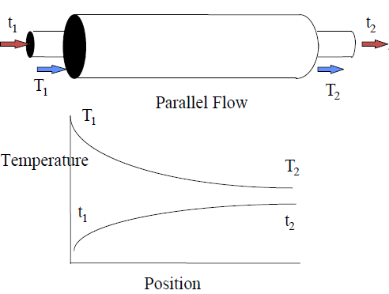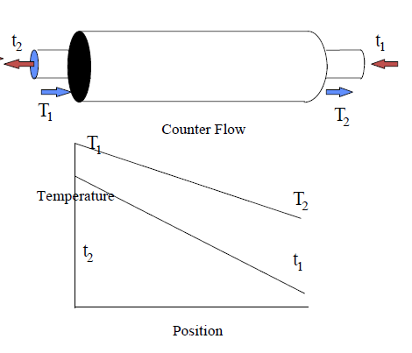Figure 6.2: Parallel Flow Heat Exchanger Figure 6.3: Counter Flow Heat Exchanger

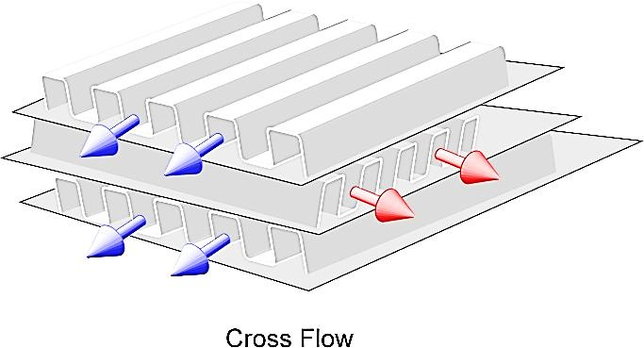

Figure 6.4: Cross Flow Heat Exchanger

**6.2.4 BASED ON DESIGN AND CONSTRUCTIONAL FEATURES:**

**a. CONCENTRIC TUBE HEAT EXCHANGERS:** In this the two concentric tubes carry two different fluids and heat exchanges between them through the inner cylindrical surface.

**b. SHELL AND TUBE HEAT EXCHANGERS:** Shell and tube heat exchanger is built of round tubes mounted in a cylindrical shell with the tube axis parallel to that of the shell. One fluid flows inside the tube, the other flows across and along the tubes. The major components of the shell and tube heat exchanger are tube bundle, shell, front end head, rear end head, baffles and tube sheets. It is shown in figure 6.5.

**c. MULTI PASS HEAT EXCHANGERS:** When large capacities are involved, the multi pass heat exchangers are widely used. Baffles are usually installed to increase the convection coefficients of the shell side fluid by inducing turbulence and cross flow velocity components. Figure 6.6 and figure 6.7 shows, one shell pass and two tube pass and two shell pass and four tube pass heat exchanger.



Figure 6.5: Shell and Tube Heat Exchanger

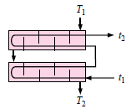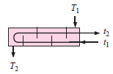

Figure 6.6: One Shell and Two Tubes Pass Figure 6.7: Two Shell and Four Tubes Pass

**6.3 OVERALL HEAT TRANSFER COEFFICIENT:**

An important step in heat exchanger analysis is determination of the overall heat transfer coefficient. This is defined in terms of the total thermal resistance to heat transfer between two fluids.

Consider a double pipe heat exchanger shown in figure 6.8

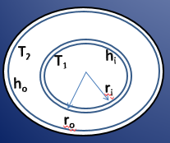

Figure 6.8: Double Pipe Heat Exchanger

Total heat transfer

$q=\frac{ T_{1}– T_{2}}{R_{total}}= UA \left( T_{1}– T_{2}\right)$… (6.1)

U based on the inside area of inner tube is

$\frac{1}{U_{i}}=\frac{1}{h_{i}}+ \left(\frac{r_{i}}{k}\right)ln\left(\frac{r_{o}}{r_{i}}\right)+\left(\frac{1}{h_{o}}\right)×\left(\frac{r_{o}}{r_{i}}\right)$… (6.2)

U based on the outside area of inner tube is

$\frac{1}{U_{o}}=\frac{1}{h_{o}}+ \left(\frac{r_{o}}{k}\right)ln\left(\frac{r_{o}}{r_{i}}\right)+\frac{1}{h_{i}}×\left(\frac{r_{o}}{r_{i}}\right)$… (6.3)

**6.4 FOULING AND FOULING FACTORS:**

When the heat exchanger has been in use for some time, its surfaces do not remain clean. The surfaces will be fouled or covered with scaling or deposits formed due to chemical reaction between the fluid and wall materials, rust formation etc.

The scale thus formed increases the surface resistance thus affecting the value of U. This effect is taken care of by introducing an additional **thermal** resistance called the **fouling resistance.**

U based on inside area of the inner tube considering scale resistance is

$U_{i}=\frac{1}{\frac{1}{h_{i}}+R_{si}+\frac{r_{i}\ln\left(\frac{r_{o}}{r_{i}}\right)}{k}+\left(\frac{1}{h_{o}}\right)×\left(\frac{r_{o}}{r_{i}}\right)+R_{so}\left(\frac{r_{i}}{r_{o}}\right)}$… (6.4)

U based on outside area of the inner tube considering scale resistance is

$U_{o}=\frac{1}{\frac{1}{h_{i}}×\left(\frac{r_{o}}{r_{i}}\right)+R_{si}\left(\frac{r_{i}}{r_{o}}\right)+\frac{r_{i}\ln\left(\frac{r_{o}}{r_{i}}\right)}{k}+\left(\frac{1}{h_{o}}\right) +R_{so}}$… (6.5)

Fouling can be caused by the following sources:

1. **Scaling**is the most common form of fouling and is associated with inverse solubility salts. Examples of such salts are CaCO3, CaSO4, Ca3(PO4)2, CaSiO3, Ca(OH)2, Mg(OH)2, MgSiO3, Na2SO4, LiSO4, and Li2CO3.
2. **Corrosion fouling**is caused by chemical reaction of some fluid constituents with the heat exchanger tube material.
3. **Chemical reaction fouling**involves chemical reactions in the process stream which results in deposition of material on the heat exchanger tubes. This commonly occurs in food processing industries.
4. **Freezing fouling**is occurs when a portion of the hot stream is cooled to near the freezing point for one of its components. This commonly occurs in refineries where paraffin frequently solidifies from petroleum products at various stages in the refining process, obstructing both flow and heat transfer.
5. **Biological fouling**is common where untreated water from natural resources such as rivers and lakes is used as a coolant. Biological micro-organisms such as algae or other microbes can grow inside the heat exchanger and hinder heat transfer.
6. **Particulate fouling**results from the presence of microscale sized particles in solution. When such particles accumulate on a heat exchanger surface they sometimes fuse and harden. Like scale these deposits are difficult to remove.

**6.5 LOGARITHMIC MEAN TEMPERATURE DIFFERENCE (LMTD):**

LMTD is defined as the temperature difference which, if constant, would give the same rate of heat transfer actually occurs under variable conditions of temperature difference.

**6.5.1 LMTD FOR PARALLEL FLOW AND COUNTER FLOW HEAT EXCHANGERS:**

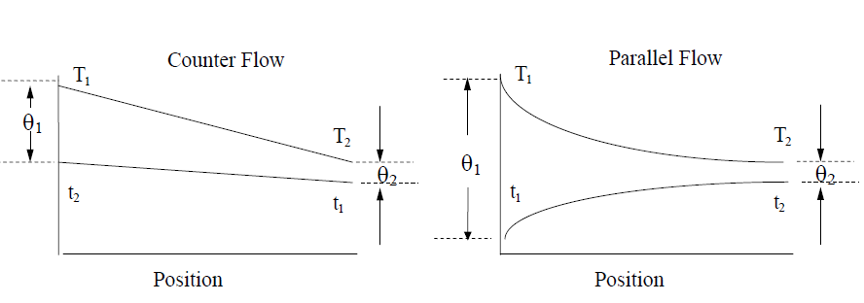

Figure 6.9: Temperature Profile Diagrams for LMTD

The integrated average temperature difference for either parallel or counter flow may be written as:

$Δθ=LMTD=\frac{θ_{1}-θ_{2}}{\ln\left(\frac{θ_{1}}{θ_{2}}\right)}$… (6.6)

Parallel Flow Heat Exchanger

$LMTD =\frac{\left[\left(T_{hi}– T_{ci}\right)-\left(T_{ho}– T_{co}\right)\right]}{ln\left[\frac{T_{hi}– T_{ci}}{T_{ho}-T_{co}}\right]}$… (6.7)

Counter Flow Heat Exchanger

$LMTD =\frac{\left[\left(T_{hi}– T_{co}\right)-\left(T_{ho}– T_{ci}\right)\right]}{ln\left[\frac{T_{hi}– T_{co}}{T_{ho}-T_{ci}}\right]}$... (6.8)

Total Heat transfer in the Heat Exchanger is given by

$q = UA \left(LMTD\right)$... (6.9)

The effective temperature difference calculated from this equation is known as the log mean temperature difference, frequently abbreviated as LMTD, based on the type of mathematical average that it describes. While the equation applies to either parallel or counter flow, it can be shown that Δθeff will always be greater in the counter flow arrangement.

Another interesting observation from the above figure 6.9 is that counter flow is more appropriate for maximum energy recovery. In a number of industrial applications there will be considerable energy available within a hot waste stream which may be recovered before the stream is discharged. This is done by recovering energy into a fresh cold stream. Note in the Figures shown above that the hot stream may be cooled to t1 for counter flow, but may only be cooled to t2 for parallel flow. Counter flow allows for a greater degree of energy recovery. Similar arguments may be made to show the advantage of counter flow for energy recovery from refrigerated cold streams.

**6.5.2 LMTD FOR CROSS FLOW AND MULTIPASS HEAT EXCHANGERS:**

The flow conditions in Multi-pass and cross flow heat exchangers are much more complicated than in concentric tube, single pass heat exchangers. For these complex conditions, the LMTD is first calculated based on counter flow arrangement and then a correction factor (FT) is applied.

To find the correction factor, we define two ratios.

**a**. **Temperature Ratio (P)** – This is the ratio of rise in temperature of the cold fluid to the difference in inlet temperature of the two fluids.

$P =\frac{T_{c2}– T_{c1}}{T_{h1}– T_{c1}}$... (6.10)

**b**. **Capacity Ratio (R)** – This is the ratio of minimum heat capacity to maximum heat capacity of the fluids.

$R =\frac{C_{min}}{C_{max}}$... (6.11)  
  Where C = m. Cp

The corrected temperature difference is given by

$∆θ_{eff}=F_{T}. LMTD_{CF}$... (6.12)

**6.5.3 APPLICATIONS FOR COUNTER AND PARALLEL FLOW:**

We have seen two advantages for counter flow, (a) larger effective LMTD and (b) greater potential energy recovery. The advantage of the larger LMTD, as seen from the heat exchanger equation, is that a larger LMTD permits a smaller heat exchanger area, Ao, for a given heat transfer, Q. This would normally be expected to result in smaller, less expensive equipment for a given application.

Sometimes, however, parallel flows are desirable (a) where the high initial heating rate may be used to advantage and (b) where it is required the temperatures developed at the tube walls are moderate. In heating very viscous fluids, parallel flow provides for rapid initial heating and consequent decrease in fluid viscosity and reduction in pumping requirement. In applications where moderation of tube wall temperatures is required, parallel flow results in cooler walls. This is especially beneficial in cases where the tubes are sensitive to fouling effects which are aggravated by high temperature.

**6.6 EFFECTIVENESS OF HEAT EXCHANGER:**

The effectiveness of a heat exchanger is defined as a ratio of actual rate of heat transfer to the maximum possible rate of heat transfer.

$ϵ =\frac{Actual rate of heat transfer}{Maximum heat transfer}$... (6.13)

The actual rate of heat transfer is the heat lost by the hot fluid or heat gained by the cold fluid. While the maximum possible heat transfer occurs in a counter flow exchanger of large surface area when

* + 1. The exit temperature of hot fluid = inlet temperature of cold fluid
    2. The exit temperature of cold fluid is equal to the inlet temperature of hot fluid.

$q_{max}= C_{min}×\left(T_{hi} - T_{ci}\right)$... (6.14)

$q_{actual}= C_{h}× \left( T_{hi} - T_{ho}\right)= C_{c}×\left( T_{co} - T_{ci}\right)$... (6.15)

Effectiveness by definition is,

$ϵ =\frac{q_{actual}}{q_{max}}$... (6.16)

$ϵ =\frac{C_{h}\left( T_{hi} - T_{ho}\right)}{C_{min}×\left( T_{hi} - T_{ci}\right)}=\frac{C_{c}\left( T_{co} - T_{ci}\right)}{C_{min}×\left( T_{hi} - T_{ci}\right)}$... (6.17)

When Ch < Cc i.e., Ch = Cmin  
 ... (6.18)  
 When Cc < Ch i.e., Cc = Cmin

... (6.19

**6.6.1 ANALYSIS BY NTU METHOD:**

LMTD method can be conveniently used when the fluid inlet temperature are known and the outlet temperatures are specified or readily determined from the energy balance expressions. However, if only the inlet temperatures are known, it is difficult to use LMTD method. In such cases, an alternative method termed Effectiveness- NTU method can be used.

$Number of Transfer Units = NTU =\frac{UA}{C_{min}}$... (6.20)

Effectiveness- NTU formula for

1. Parallel Flow Heat Exchanger

$ϵ =\frac{1 – e^{–NTU\left(1+R\right)}}{1+ R}$... (6.21)

1. Counter Flow Heat Exchanger

$ϵ =\frac{1 – e^{–NTU\left(1-R\right)}}{1 – {Re}^{–NTU\left(1-R\right)}}$... (6.22)

**SUMMARY**

1. Heat exchangers remove heat from a high temperature fluid by convection and conduction.
2. Counter- flow heat exchangers typically remove more heat than parallel-flow heat exchangers.
3. Parallel flow heat exchangers have a large temperature difference at inlet and a small temperature difference at the outlet.
4. Counter- flow heat exchangers have an even temperature difference across the heat transfer length.
5. Regenerative heat exchangers improve system efficiency by returning energy to the system. A non- regenerative heat exchanger rejects heat to the surroundings.
6. The heat transfer rate for a heat exchanger can be calculated using the equation below.

Q= UAΔT

**CHAPTER 7**

**TWO-FLUID HEAT EXCHANGER**

**7.1 INTRODUCTION:**

Two fluid heat exchangers are one of the most basic and widely used heat exchangers, due to its relatively simple design and efficiency it finds various applications in the field of power plants, automotive exhaust heat recovery, boilers.

**7.1.1 BACKGROUND AND METHODOLOGY:**

The construction involves two fluid carrying medium in a parallel arrangement through which fluid enters or leaves and has thermal interaction with the fluid in the next medium, depending on the direction of flow the effectiveness of the exchanger is altered considering all possible thermal interactions and flow arrangements. The equations are proposed to be solved by FEM. Validation of the methodology will be made by comparing the solutions obtained through FEM for cases involving no losses and comparing them with those published in research papers for similar situations. Further the methodology will be extended to understand the effect of longitudinal wall conduction effects on the temperature profiles of the three fluids and the effectiveness of the heat exchanger.

To study the thermal performance of both co-current and counter-current parallel flow heat exchangers, it is assumed that one of the fluid is hot and the other being cold having thermal interaction between them.

The dimensionless governing equations are derived based on the conservation of energy principle and solved using FEM based on subdomain collocation method and Galerkin’s method. The results show that the subdomain collocation method is more accurate than the Galerkin’s method, as observed when the results obtained are compared with the analytical results for the classical two-fluid heat exchangers.

**7.1.2 PROCESSES IN A TWO FLUID HEAT EXCHANGER:**

There are three identified engineering goals of two-fluid heat exchangers, which are:

1. Heating the cold fluid
2. Cooling the hot fluid
3. Maximizing the enthalpy change of the central fluid stream or the lateral fluid Streams.

**7.2 GOVERNING EQUATIONS:**

Consider steady state flow of hot and cold fluids as shown in the figure. The boundary conditions are given by specifying the inlet temperatures of the two fluids. Applying the law of conservation of energy principle to both the fluids, the following equations are derived:

Thi Th0

Tci Tc0

(a)

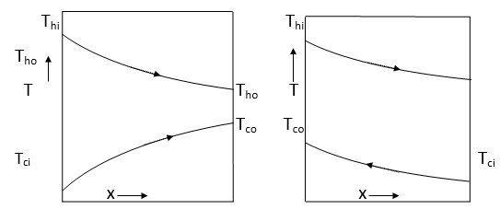

((b) (c)

Figure 7.1: Schematic Diagram and Temperature Profile for Two-Fluid Parallel and Counter Flow Heat Exchangers

**Hot Fluid:**

$C_{h}\frac{{dT}_{h}}{dx}=-UP[T_{h}-T_{c}]$... (7.1)

$\frac{{dT}_{h}}{dx}=\frac{-UP}{C_{h}}[T_{h}-T_{c}]$... (7.2)

$\frac{{dT}_{h}}{dx}+\frac{UP}{C_{h}}\left[T_{h}-T_{c}\right]=0$... (7.3)

**Cold Fluid:**

$C_{c}\frac{{dT}_{c}}{dx}=±UP[T_{h}-T_{c}]$... (7.4)

$\frac{{dT}_{c}}{dx}=±\frac{UP}{C_{c}}[T_{h}-T_{c}]$... (7.5)

$\frac{{dT}_{c}}{dx}∓\frac{UP}{C_{c}}\left[T_{h}-T_{c}\right]=0$... (7.6)

In order to simplify and generalize the equations, the following dimensionless variables are introduced:

$θ=\frac{T-T_{ci}}{T_{hi-}T_{ci}}$ and $X=\frac{x}{L_{e}}$... (7.7)

Where Le is the length of the element given by $L_{e}=\frac{L}{N}$;

It can be shown that the dimensionless forms of the equations are:

$\frac{dθ_{h}}{dX}+\frac{UPL}{C_{h}}\left[θ_{h}{-θ}_{c}\right]=0$... (7.8)

$\frac{dθ_{c}}{dX}∓\frac{UPL}{C_{c}}\left[θ_{h}{-θ}_{c}\right]=0$... (7.9)

Here the positive sign is for counter current flow and negative sign is for co- current flow.

The governing parameters can be combined together in order to simplify the equations as follows:

$Ntu=\frac{{UPL}_{e}}{C_{h}}$ and $R=\frac{C_{h}}{C_{c}}{Ntu}_{e}=\frac{Ntu}{N}$... (7.10)

Therefore the final forms of the dimensionless governing equations are:

$\frac{dθ_{h}}{dX}+{Ntu}_{e}\left[θ_{h}{-θ}_{c}\right]=0$... (7.11)

$\frac{dθ_{c}}{dX}±{Ntu}_{e}R\left[θ_{h}{-θ}_{c}\right]=0$... (7.12)

The above equations can be solved with the specified inlet temperatures to find the outlet temperatures of the two fluids. Therefore the boundary conditions can be defined as: $θ_{hi}=1$ and $θ_{ci}=0$.

**7.3 SOLVING THE GOVERNING EQUATIONS- PARALLEL FLOW:**

**7.3.1 SUBDOMAIN COLLOCATION METHOD:**

We integrate the governing equations with limits 0 to 1(1-D element). In sub-domain collocation method, we take the weighted residual W equal to 1 to solve the equations.

Here the weighted parameter is taken as 1, i.e. W=1;

$θ_{h}=N_{1}θ_{hi}+N_{2}θ_{ho}$... (7.13)

$θ_{c}=N_{1}θ_{ci}+N_{2}θ_{co}$... (7.14)

$N_{1}=1-X; N_{2}=X$... (7.15)

$\frac{{dθ}_{h}}{dX}=\left[\frac{d\left(N_{1}θ_{hi}+N_{2}θ_{ho}\right)}{dX}\right]=-θ_{hi}+θ_{ho}$... (7.16)

$\frac{{dθ}_{c}}{dX}=\left[\frac{d\left(N_{1}θ_{ci}+N_{2}θ_{co}\right)}{dX}\right]=-θ_{ci}+θ_{co}$... (7.17)

Substituting for the above we get the FEM equations as follows:

**Hot fluid:**

$\int_{0}^{1}{1[\frac{{dθ}_{h}}{dX}+Ntu*(θ_{h}-θ_{c}})]dX=0$... (7.18)

$\int_{0}^{1}{\left[{(-θ}_{hi}+θ_{ho}\right)+{Ntu}_{e}*\{\left(N_{1}θ_{hi}+N_{2}θ_{ho}\right)-\left(N_{1}θ_{ci}+N_{2}θ_{co}\right)\}]dX}=0$... (7.19)

$θ_{hi}\left(\frac{{Ntu}_{e}}{2}-1\right)+θ_{ci}\left(\frac{-{Ntu}_{e}}{2}\right)+θ_{ho}\left(\frac{{Ntu}_{e}}{2}+1\right)+θ_{co}\left(\frac{-{Ntu}_{e}}{2}\right)=0$... (7.20)

**Cold fluid:**

$\int_{0}^{1}{1[\frac{{dθ}_{c}}{dX}-Ntu*R*(θ_{h}-θ_{c}})]dX=0$... (7.21)

$\int_{0}^{1}{\left[{(-θ}_{ci}+θ_{co}\right)-Ntu*R*\{\left(N_{1}θ_{hi}+N_{2}θ_{ho}\right)-\left(N_{1}θ_{ci}+N_{2}θ_{co}\right)\}]dX=0}$... (7.22)

$θ_{hi}\left(\frac{{-Ntu}_{e}*R}{2}\right)+θ_{ci}\left(\frac{{Ntu}_{e}*R}{2}-1\right)+θ_{ho}\left(\frac{{-Ntu}_{e}*R}{2}\right)+θ_{co}\left(\frac{{Ntu}_{e}*R}{2}+1\right)=0$... (7.23)

Boundary conditions $θ_{hi}=1,θ_{ci}=0$, can be written in matrix form as follows:

1 0 0 0 θhi 1

0 1 0 0 θci =0

a-1 -a a+1 -a θho 0

-b b-1 -b b+1 θco 0

a=NTUe/2; ... (7.24)

b=NTUe*R/2; ... (7.25)

**7.3.2 GALERKIN’S METHOD:**

Here shape functions $N_{1} and N_{2}$ are taken as weighted parameters and are given by:

$N_{1}=1-X; N_{2}=X$... (7.26)

$θ_{h}=N_{1}θ_{hi}+N_{2}θ_{ho}$... (7.27)

$θ_{c}=N_{1}θ_{ci}+N_{2}θ_{co}$... (7.28)

$N_{1}=1-X; N_{2}=X$... (7.29)

$\frac{{dθ}_{h}}{dX}=\frac{d\left(N_{1}θ_{hi}+N_{2}θ_{ho}\right)}{dX}={-θ}_{hi}+θ_{ho}$... (7.30)

$\frac{{dθ}_{c}}{dX}=\frac{d\left(N_{1}θ_{ci}+N_{2}θ_{co}\right)}{dX}=-θ_{ci}+θ_{co}$... (7.31)

Substituting for the above we get the FEM equations as follows:

**Hot fluid:**

$\int_{0}^{1}{N_{1}[\frac{{dθ}_{h}}{dx}+{Ntu}_{e}*(θ_{h}-θ_{c}})]dX=0$... (7.32)

$\int_{0}^{1}{N_{1}\left[{(θ_{ho}-θ}_{hi}\right)+{Ntu}_{e}*\{\left(N_{1}θ_{hi}+N_{2}θ_{ho}\right)-\left(N_{1}θ_{ci}+N_{2}θ_{co}\right)\}]dX=0}$... (7.33)

$θ_{hi}\left(\frac{{Ntu}_{e}}{3}-0.5\right)+θ_{ci}\left(\frac{-{Ntu}_{e}}{3}\right)+θ_{ho}\left(\frac{{Ntu}_{e}}{6}+0.5\right)+θ_{co}\left(\frac{-{Ntu}_{e}}{6}\right)=0$... (7.34)

$\int_{0}^{1}{N_{2}[\frac{{dθ}_{h}}{dx}+{Ntu}_{e}*(θ_{h}-θ_{c}})]dX=0$... (7.35)

$\int_{0}^{1}{N_{2}\left[{(θ_{ho}-θ}_{hi}\right)+{Ntu}_{e}*\{\left(N_{1}θ_{hi}+N_{2}θ_{ho}\right)-\left(N_{1}θ_{ci}+N_{2}θ_{co}\right)\}]dX=0}$... (7.36)

$θ_{hi}\left(\frac{{Ntu}_{e}}{6}-0.5\right)+θ_{ci}\left(\frac{-{Ntu}_{e}}{6}\right)+θ_{ho}\left(\frac{{Ntu}_{e}}{3}+0.5\right)+θ_{co}\left(\frac{-{Ntu}_{e}}{3}\right)=0$... (7.37)

**Cold fluid:**

$\int_{0}^{1}{N_{1}[\frac{{dθ}_{c}}{dx}-{Ntu}_{e}*R*(θ_{h}-θ_{c}})]dX=0$... (7.38)

$\int_{0}^{1}{N_{1}\left[{(θ}_{co}-θ_{ci}\right)-Ntu*R*\{\left(N_{1}θ_{hi}+N_{2}θ_{ho}\right)-\left(N_{1}θ_{ci}+N_{2}θ_{co}\right)\}]dX}=0$... (7.39)

$θ_{hi}\left(\frac{{-Ntu}_{e}*R}{3}\right)+θ_{ci}\left(\frac{{Ntu}_{e}*R}{3}-0.5\right)+θ_{ho}\left(\frac{{-Ntu}_{e}*R}{6}\right)+θ_{co}\left(\frac{{Ntu}_{e}*R}{6}+0.5\right)=0$... (7.40)

$\int_{0}^{1}{N_{2}[\frac{{dθ}_{c}}{dx}-{Ntu}_{e}*R*(θ_{h}-θ_{c}})]dX=0$... (7.41)

$\int_{0}^{1}{N_{2}\left[{(θ}_{co}-θ_{ci}\right)-Ntu*R*\{\left(N_{1}θ_{hi}+N_{2}θ_{ho}\right)-\left(N_{1}θ_{ci}+N_{2}θ_{co}\right)\}]dX=0}$... (7.42)

$θ_{hi}\left(\frac{{-Ntu}_{e}*R}{6}\right)+θ_{ci}\left(\frac{{Ntu}_{e}*R}{6}-0.5\right)+θ_{ho}\left(\frac{{-Ntu}_{e}*R}{3}\right)+θ_{co}(\frac{{Ntu}_{e}*R}{3}+0.5)=0$... (7.43)

[K] $\left\{θ\right\}=\left\{f\right\}$... (7.44)

Boundary conditions $θ_{hi}=1,θ_{ci}=0$, can be written in matrix form as follows:

a-0.5 -a a/2+0.5 -a/2 θhi 1

-b b-0.5 -b/2 b/2+0.5 θci =0

a/2-0.5 -a/2 a+0.5 -a θho 0

-b/2 b/2-0.5 -b b+0.5 θco 0

a=NTUe/3;

b=NTUe*R/3;

**7.4 SOLVING THE GOVERNING EQUATIONS- COUNTER FLOW:**

**7.4.1 SUBDOMAIN COLLOCATION METHOD:**

$θ_{h}=N_{1}θ_{hi}+N_{2}θ_{ho}$... (7.45)

${ θ}_{c}=N_{2}θ_{ci}+N_{1}θ_{co}$... (7.46)

$N_{1}=1-X; N_{2}=X$... (7.47)

$\frac{{dθ}_{h}}{dX}=\frac{d\left(N_{1}θ_{hi}+N_{2}θ_{ho}\right)}{dX}={-θ}_{hi}+θ_{ho}$... (7.48)

$\frac{{dθ}_{c}}{dX}=\frac{d\left(N_{2}θ_{ci}+N_{1}θ_{co}\right)}{dX}=θ_{ci}-θ_{co}$... (7.49)

Substituting for the above we get the FEM equations as follows:

**Hot Fluid:**

$\int_{0}^{1}{1[\frac{{dθ}_{h}}{dx}+Ntu*(θ_{h}-θ_{c}})]dX=0$... (7.50)

$\int_{0}^{1}{\left[{(θ}_{hi}-θ_{ho}\right)+Ntu*\{\left(N_{1}θ_{hi}+N_{2}θ_{ho}\right)-\left(N_{2}θ_{ci}+N_{1}θ_{co}\right)\}]dX=0}$... (7.51)

$θ_{hi}\left(\frac{{Ntu}_{e}}{2}-1\right)+θ_{co}\left(\frac{-{Ntu}_{e}}{2}\right)+θ_{ho}\left(\frac{{Ntu}_{e}}{2}+1\right)+θ_{ci}\left(\frac{-{Ntu}_{e}}{2}\right)=0$... (7.52)

**Cold Fluid:**

$\int_{0}^{1}{1[\frac{{dθ}_{c}}{dx}+Ntu*R*(θ_{h}-θ_{c}})]dX=0$... (7.53)

$\int_{0}^{1}{\left[{(θ}_{co}-θ_{ci}\right)+Ntu*R*\{\left(N_{1}θ_{hi}+N_{2}θ_{ho}\right)-\left(N_{2}θ_{ci}+N_{1}θ_{co}\right)\}]dX=0}$... (7.54)

$θ_{hi}\left(\frac{{Ntu}_{e}*R}{2}\right)+θ_{co}\left(-\frac{{Ntu}_{e}*R}{2}-1\right)+θ_{ho}\left(\frac{{Ntu}_{e}}{2}\right)+θ_{ci}\left(-\frac{{Ntu}_{e}*R}{2}+1\right)=0$... (7.55)

Boundary conditions $θ_{hi}=1,θ_{ci}=0$, can be written in matrix form as follows:

1 0 0 0 θhi 1

0 0 0 1 θco =0

a-1 -a a+1 -a θho 0

b -b-1 b -b+1 θci 0

a= Ntue/2;

b = Ntue*R/2;

**7.4.2 GALERKIN’S METHOD:**

$θ_{h}=N_{1}θ_{hi}+N_{2}θ_{ho}$... (7.56)

$θ_{c}=N_{2}θ_{ci}+N_{1}θ_{co}$... (7.57)

$N_{1}=1-X; N_{2}=X$... (7.58)

$\frac{{dθ}_{h}}{dX}=\frac{d\left(N_{1}θ_{hi}+N_{2}θ_{ho}\right)}{dX}={-θ}_{hi}+θ_{ho}$... (7.59)

$\frac{{dθ}_{c}}{dX}=\frac{d\left(N_{2}θ_{ci}+N_{1}θ_{co}\right)}{dX}=+θ_{ci}-θ_{co}$... (7.60)

Substituting for the above we get the FEM equations as follows:

**Hot Fluid:**

$\int_{0}^{1}{N_{1}[\frac{{dθ}_{h}}{dx}+Ntu*(θ_{h}-θ_{c}})]dX=0$... (7.62)

$\int_{0}^{1}{N_{1}\left[{(θ}_{hi}-θ_{ho}\right)+Ntu*\{\left(N_{1}θ_{hi}+N_{2}θ_{ho}\right)-\left(N_{2}θ_{ci}+N_{1}θ_{co}\right)\}]dX=0}$... (7.63)

$θ_{hi}\left(\frac{{Ntu}_{e}}{3}-0.5\right)+θ_{ci}\left(\frac{-{Ntu}_{e}}{3}\right)+θ_{ho}\left(\frac{{Ntu}_{e}}{6}+0.5\right)+θ_{co}\left(\frac{-{Ntu}_{e}}{6}\right)=0$... (7.64)

$\int_{0}^{1}{N_{2}[\frac{{dθ}_{h}}{dx}+Ntu*(θ_{h}-θ_{c}})]dX=0$... (7.65)

$\int_{0}^{1}{N_{2}\left[{(θ}_{hi}-θ_{ho}\right)+Ntu*\{\left(N_{1}θ_{hi}+N_{2}θ_{ho}\right)-\left(N_{2}θ_{ci}+N_{1}θ_{co}\right)\}]dX=0}$... (7.66)

$θ_{hi}\left(\frac{{Ntu}_{e}}{6}-0.5\right)+θ_{ci}\left(\frac{-{Ntu}_{e}}{6}\right)+θ_{ho}\left(\frac{{Ntu}_{e}}{3}+0.5\right)+θ_{co}\left(\frac{-{Ntu}_{e}}{3}\right)=0$... (7.67)

**Cold Fluid:**

$\int_{0}^{1}{N_{1}[\frac{{dθ}_{c}}{dx}+Ntu*R*(θ_{h}-θ_{c}})]dX=0$... (7.68)

$\int_{0}^{1}{N_{1}\left[{(θ}_{ci}-θ_{co}\right)+Ntu*R*\{\left(N_{1}θ_{hi}+N_{2}θ_{ho}\right)-\left(N_{2}θ_{ci}+N_{1}θ_{co}\right)\}]dX}=0$... (7.69)

$θ_{hi}\left(\frac{{Ntu}_{e}*R}{3}\right)+θ_{co}\left(-\frac{{Ntu}_{e}*R}{3}-0.5\right)+θ_{ho}\left(\frac{{Ntu}_{e}*R}{6}\right)+θ_{ci}\left(-\frac{{Ntu}_{e}*R}{6}+0.5\right)=0$... (7.70)

$\int_{0}^{1}{N_{2}[\frac{{dθ}_{c}}{dx}+Ntu*R*(θ_{h}-θ_{c}})]dX=0$... (7.71)

$\int_{0}^{1}{N_{2}\left[{(θ}_{ci}-θ_{co}\right)+Ntu*R*\{\left(N_{1}θ_{hi}+N_{2}θ_{ho}\right)-\left(N_{2}θ_{ci}+N_{1}θ_{co}\right)\}]dX=0}$... (7.72)

$θ_{hi}\left(\frac{{Ntu}_{e}*R}{6}\right)+θ_{co}\left(-\frac{{Ntu}_{e}*R}{6}-0.5\right)+θ_{ho}\left(\frac{{Ntu}_{e}*R}{3}\right)+θ_{ci}\left(-\frac{{Ntu}_{e}*R}{3}+0.5\right)=0$... (7.73)

Boundary conditions $θ_{hi}=1,θ_{ci}=0$, can be written in matrix form as follows:

a- 0.5 -a a/2+0.5 -a/2 θhi 1

b -b-0.5 b/2 -b/2+0.5 θci =0

a/2- 0.5 -a/2 a+0.5 -a θho 0

b/2 -b/2-0.5 b b+0.5 θco 0

a=NTUe/3;

b=NTUe*R/3;

**SUMMARY**

1. Finite Element Method can be used to analyse two fluid heat exchangers with good accuracy.
2. Effectiveness of counter flow heat exchanger is more than parallel flow heat exchanger operating under same conditions.
3. The convergence of solution is observed at lesser number of elements in Sub-domain collocation method as compared to Galerkin’s method.

**CHAPTER 8**

**THREE-FLUID HEAT EXCHANGER**

**8.1 INTRODUCTION:**

Three fluid heat exchangers, involving all the three fluids in thermal communication [11] [12], are used in several applications found in aerospace, petro-chemical and chemical industries to name a few. Systems that deal with ammonia gas synthesis and purification and liquefaction of hydrogen, air separation systems, helium-air separation units are typical applications which make use of three fluid heat exchangers.

**8.1.1 BACKGROUND AND METHODOLOGY:**

Sekulic and Shah (1995) have presented in detail a review on thermal design theory of three-fluid heat exchangers, where they have allowed the third fluid temperature to vary according to the prevailing thermal communications while neglecting interaction with the ambient.

In this project it is proposed to write governing equations for a three fluid heat exchanger that can be applied for all three fluid, single pass, parallel and counter flow heat exchangers considering all possible thermal interactions and flow arrangements [13]. The equations are proposed to be solved by FEM. Validation of the methodology will be made by comparing the solutions obtained through FEM for cases involving no losses and comparing them with those published in research papers for similar situations. Further the methodology will be extended to understand the effect of longitudinal wall conduction effects on the temperature profiles of the three fluids and the effectiveness of the heat exchanger.

To study the thermal performance of both co-current and counter-current parallel flow heat exchangers. The hot stream is assumed to flow in the middle of two cold streams and exchange heat with them.

The dimensionless governing equations are derived based on the conservation of energy principle and solved using FEM based on subdomain collocation method and Galerkin’s method. The results show that the subdomain collocation method is more accurate than the Galerkin’s method, as observed when the results obtained are compared with the analytical results for the classical two-fluid heat exchangers.

**8.1.2 PROCESSES IN A THREE FLUID HEAT EXCHANGER:**

There are five identified engineering goals of three-fluid heat exchangers, which are:

1. Heating the cold fluid
2. Cooling the hot fluid
3. Cooling the intermediate fluid
4. Heating the intermediate fluid and
5. Maximizing the enthalpy change of the central fluid stream or the lateral fluid Streams.

**8.2 GOVERNING EQUATIONS:**

Consider the steady-state flow of the hot fluid in the middle channel between two steady-state parallel flows or two counter flow cold fluids as shown. The boundary conditions are given by specifying the inlet temperatures of the three streams [14]. To generalize the formulations, it is assumed that the overall heat transfer coefficient U between the hot fluid and the two cold fluids are different. Variable contact areas between the hot channel and the two cold fluids are assumed. 1-D Conduction-Convection element is used for analysis.



Figure 8.1: Schematic Diagram for Three-Fluid Parallel and Counter Flow Heat Exchangers

Applying the conservation of energy principle for each of the three streams, the following equations are derived:

$m_{c1 }C_{pc1}\frac{∂T_{c1}}{∂x} = ± U_{1}P_{1}\left(T_{h}-T_{c1}\right)$... (8.1)

$m_{h }C_{ph}\frac{∂T_{h}}{∂x} = - U_{1}P_{1}\left(T_{h}-T_{c1}\right)-U_{2}P_{2}\left(T_{h}-T_{c2}\right)$... (8.2)

$m_{c2 }C_{pc2}\frac{∂T_{c2}}{∂x} = ± U_{2}P_{2}\left(T_{h}-T_{c2}\right)$... (8.3)

Where the positive sign in equations is for parallel flow and the negative sign is for the counter flow, U1 and U2 are the overall heat transfer coefficient between the hot fluid and c1 cold fluid and c2 cold fluid, respectively. P1 and P2 are the contact perimeter with the hot channel of c1 channel and c2 channel, respectively.

In order to simplify and generalize the equations, the following dimensionless variables are introduced:

$θ= \frac{T-T_{cin}}{T_{hin}-T_{c1}}; X= \frac{x}{L_{e}}$... (8.4)

Where *Le* is the length of the element and the inlet temperatures of the two cold streams need not be equal. It can be shown that the dimensionless forms of the governing equations are:

$\frac{dθ_{c1}}{dx}= ±\frac{U_{1}P_{1}L_{e}}{m_{c1}C_{pc1}}\left(θ_{h}-θ_{c1}\right)$... (8.5)

$\frac{dθ_{h}}{dx}= -\frac{U_{1}P_{1}L_{e}}{m_{h}C_{ph}}\left(θ_{h}-θ_{c1}\right)-\frac{U_{2}P_{2}L_{e}}{m_{h}C_{ph}}\left(θ_{h}-θ_{c2}\right)$... (8.6)

$\frac{dθ_{c2}}{dx}= ±\frac{U_{2}P_{2}L_{e}}{m_{c2}C_{pc2}}(θ_{h}-θ_{c2})$... (8.7)

The governing parameters can be combined together in order to reduce the number of the parameters as follows:

${NTU}_{e}=\frac{U_{1}P_{1}L_{e}}{m_{h}C_{ph}} ; R_{1}=\frac{m_{h}C_{ph}}{m_{c1}C_{pc1}} ; R_{2}=\frac{m_{h}C_{ph}}{m_{c2}C_{pc2}} ; H=\frac{U_{2}P_{2}}{U_{1}P_{1}}$... (8.8)

Therefore, the final forms of the dimensionless governing equations are:

$\frac{dθ_{c1}}{dx}= ±{NTU}_{e}R_{1}\left(θ_{h}-θ_{c1}\right)$... (8.9)

$\frac{dθ_{h}}{dx}= -{NTU}_{e}R_{1}\left(θ_{h}-θ_{c1}\right)-{NTU}_{e}H\left(θ_{h}-θ_{c2}\right)$... (8.10)

$\frac{dθ_{c2}}{dx}= ±{NTU}_{e}R_{2}(θ_{h}-θ_{c2)}$... (8.11)

Equations above should be solved with the specified inlet temperatures to find the outlet temperatures from each channel. Therefore the dimensionless boundary conditions can be defined as: $θ_{hin}$ = 1, $θ_{c1in}$ =0 and $θ_{c2in}$ = 0.

**8.3 SOLVING THE GOVERNING EQUATIONS:**

**8.3.1 SUBDOMAIN COLLOCATION METHOD:**

We integrate the governing equations with limits 0 to 1(1-D element). In sub-domain collocation method, we take the weighted residual W equal to 1 to solve the equations.

$\int_{0}^{1}{W\left\{\frac{dθ_{c1}}{dx}= ±{NTU}_{e}R_{1}\left(θ_{h}-θ_{c1}\right)\right\}dX=0}$... (8.12)

$\int_{0}^{1}{W\left\{\frac{dθ_{c1}}{dx}= -{NTU}_{e}R_{1}\left(θ_{h}-θ_{c1}\right)-{NTU}_{e}H\left(θ_{h}-θ_{c2}\right)\right\}dX=0}$... (8.13)

$\int_{0}^{1}{W\left\{\frac{dθ_{c2}}{dx}= ±{NTU}_{e}R_{2}\left(θ_{h}-θ_{c2}\right)\right\}dX=0}$... (8.14)

Assuming a linear variation of the hot and cold fluids in a single element for parallel flow:

$θ_{h}=N_{1}θ_{hi}+N_{2}θ_{h0}$... (8.15)

$θ_{c1}=N_{1}θ_{c1i}+N_{2}θ_{c1o}$... (8.16)

$θ_{c2}=N_{1}θ_{c2i}+N_{2}θ_{c2o}$... (8.17)

Where N1 and N2 are shape functions

N1 = 1-X; N2=X considering a linear variation. ... (8.18)

Assuming a linear variation of the hot and cold fluids in a single element for counter flow:

$θ_{h}=N_{1}θ_{hi}+N_{2}θ_{h0}$... (8.19)

$θ_{c1}=N_{2}θ_{c1i}+N_{1}θ_{c1o}$... (8.20)

$θ_{c2}=N_{2}θ_{c2i}+N_{1}θ_{c2o}$... (8.21)

Where N1 and N2 are shape functions

N1 = 1-X; N2=X considering a linear variation. ... (8.22)

**8.3.2 GALERKIN’S METHOD:**

We integrate the governing equations with limits 0 to 1(1-D element). In sub-domain collocation method, we take the weighted residual W equal to shape functions N1 = 1-X; N2=X to solve the equations.

**8.4 SOLUTION:**

1. Substitution of these approximations in equations the set of three algebraic equations can be obtained where the weighted parameter *W* is taken to be unity.
2. If the number of elements is more than one, care should be taken in assigning correct boundary conditions, where in these cases the outlet temperature from one element is equal to the inlet temperature to the next element in the direction of the fluid flow.
3. Therefore the discretized governing equations can be written in matrix form for each element as:

[K]{θ} = {f } ... (8.23)

Where [K] is known as the stiffness matrix and it is (6×6) matrix for each element

On integration after substitution, the matrix is obtained as follows for parallel flow

[K]= -0.5+a+c -a -c 0.5+a/2+c/2 -a/2 -c/2

-b -0.5+b 0 -b/2 0.5+b/2 0

-d 0 -0.5+d -d/2 0 0.5+d/2

-0.5+a/2+c/2 -a/2 -c/2 0.5+a+c -a -c

-b/2 -0.5+b/2 0 -b 0.5+b 0

-d/2 0 -0.5+d/2 -d 0 0.5+d

Where, a= ${NTU}_{e}$/3; c=a*h; ... (8.24)

b=*R1/3; d=a*R2*h;

The matrix is obtained as follows for counter flow

[K]= -0.5+a+c -a -c 0.5+a/2+c/2 -a/2 -c/2

b -0.5-b 0 b/2 0.5-b/2 0

d 0 -0.5-d d/2 0 0.5-d/2

-0.5+a/2+c/2 -a/2 -c/2 0.5+a+c -a -c

b/2 -0.5-b/2 0 b 0.5-b 0

d/2 0 -0.5-d/2 d 0 0.5-d

Where, a= /3; b=*R1/3; ... (8.25)

c=a*h; d=a*R2*h;

= and ... (8.26)

For solving, the boundary conditions are taken as BC1=1; BC2=0; BC3=0.

**8.5 CONVERGENCE TEST FOR A UNIQUE CASE:**

**8.5.1 PROPERTIES OF THE CASE:**

1. The dimensionless variables R1, R2 and h are all assumed zero.
2. Under the assumption of Cmin=0, the analytical effectiveness of all heat exchangers is the same and is given by

**ϵ = 1- e (-NTU)** ... (8.27)

1. Using this formula for analytical effectiveness in the MATLAB code to test convergence of Finite Element solutions.
2. Similar to the previous tests, the number of elements is varied at different NTU values. Analytical effectiveness and effectiveness from Finite Element method is compared.

**SUMMARY**

1. Finite element methods can be used to analyze three fluid heat exchangers. The process is cumbersome but when coded in MATLAB, the solution is simplified.
2. For same operating conditions, the effectiveness of three-fluid heat exchanger was more than that for a two fluid heat exchanger.
3. There is no exact formula for analytical effectiveness of three fluid heat exchangers as the heat exchanges are complex to analyze.
4. More number of elements was required to observe convergence of solution because the heat interactions are higher and complex.
5. The case study convergence proves the correctness of the three-fluid heat exchanger MATLAB code. Hence the code is used to analyse parallel and counter flow arrangements.

**CHAPTER 9**

**RESULTS AND DISCUSSIONS**

**9.1 TWO FLUID PARALLEL FLOW RESULTS – SUBDOMAIN COLLOCATION METHOD:**

**9.1.1 RESULT TABLE:** The finite element method explained above was coded using MATLAB. The values of effectiveness for varying number of elements at different values of NTU were tabulated as follows:

|  |  |  |  |  |  |  |  |  |
| --- | --- | --- | --- | --- | --- | --- | --- | --- |
| **NTU** | **ANALYTICAL VALUE** | **1E** | **2E** | **4E** | **8E** | **16E** | **32E** | **64E** |
| **0.5** | 0.3518 | 0.3636 | 0.3546 | 0.3525 | 0.3519 | 0.3518 | 0.3518 | 0.3518 |
| **1** | 0.5179 | 0.5174 | 0.5289 | 0.5206 | 0.5186 | 0.5181 | 0.518 | 0.5179 |
| **1.5** | 0.5964 | 0.7059 | 0.6144 | 0.6006 | 0.5974 | 0.5967 | 0.5965 | 0.5964 |
| **2** | 0.6335 | 0.8 | 0.6531 | 0.6382 | 0.6346 | 0.6338 | 0.6335 | 0.6335 |
| **2.5** | 0.6510 | 0.8696 | 0.6660 | 0.6553 | 0.6521 | 0.6513 | 0.6511 | 0.6510 |
| **3** | 0.6593 | 0.9231 | 0.6644 | 0.6626 | 0.6601 | 0.6593 | 0.6593 | 0.6593 |

Table 9.1: Sub-Domain Collocation Method Two Fluid Parallel Flow

**9.1.2 PLOT:** Plots of effectiveness vs number of elements was plotted at different values of NTU for parallel flow condition 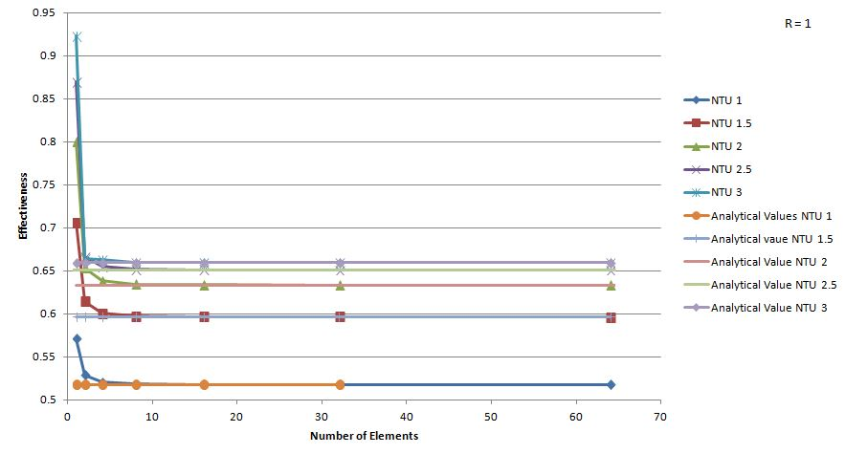

Figure 9.1: Plot of Effectiveness vs Number of Elements

**9.2 TWO FLUID PARALLEL FLOW RESULTS – GALERKIN’S METHOD:**

**9.2.1 RESULTS TABLE:** The finite element method explained above was coded using MATLAB. The values of effectiveness for varying number of elements at different values of NTU were tabulated as follows:

|  |  |  |  |  |  |  |  |  |
| --- | --- | --- | --- | --- | --- | --- | --- | --- |
| **NTU** | **ANALYTICAL VALUE** | **1E** | **2E** | **4E** | **8E** | **16E** | **32E** | **64E** |
| **0.5** | 0.3518 | 0.3333 | 0.3495 | 0.3512 | 0.3516 | 0.3517 | 0.3517 | 0.3518 |
| **1** | 0.5179 | 0.5000 | 0.5128 | 0.5165 | 0.5175 | 0.5178 | 0.5179 | 0.5179 |
| **1.5** | 0.5964 | 0.5900 | 0.5919 | 0.5948 | 0.5960 | 0.5963 | 0.5964 | 0.5964 |
| **2** | 0.6335 | 0.6267 | 0.6316 | 0.6322 | 0.6331 | 0.6334 | 0.6335 | 0.6335 |
| **2.5** | 0.6510 | 0.6488 | 0.65 | 0.6502 | 0.6507 | 0.6509 | 0.6510 | 0.6510 |
| **3** | 0.6593 | 0.657 | 0.6581 | 0.6589 | 0.6591 | 0.6592 | 0.6592 | 0.6593 |

Table 9.2: Galerkin’s Method Two Fluid Parallel Flow

**9.2.2 PLOTS:** Plots of effectiveness vs number of elements was plotted at different values of NTU for parallel flow condition

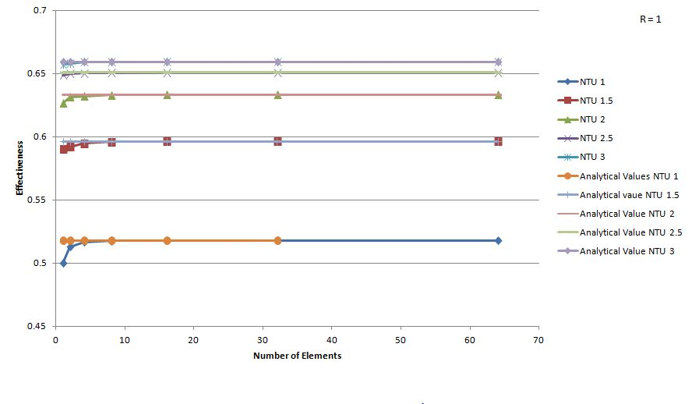Figure 9.2: Plot of Effectiveness vs Number of Elements

**9.3 TWO FLUID COUNTER FLOW RESULTS – SUBDOMAIN COLLOCATION METHOD:**

**9.3.1 RESULTS TABLE**: The finite element method explained above was coded using MATLAB. The values of effectiveness for varying number of elements at different values of NTU were tabulated as follows:

|  |  |  |  |  |  |  |  |  |
| --- | --- | --- | --- | --- | --- | --- | --- | --- |
| **NTU** | **ANALYTICAL VALUE** | **1E** | **2E** | **4E** | **8E** | **16E** | **32E** | **64E** |
| **0.5** | 0.36227 | 0.36364 | 0.36261 | 0.36235 | 0.36229 | 0.36227 | 0.36227 | 0.36227 |
| **1.0** | 0.56473 | 0.57143 | 0.56637 | 0.56514 | 0.56484 | 0.56476 | 0.56474 | 0.56473 |
| **1.5** | 0.69079 | 0.70588 | 0.69439 | 0.69168 | 0.69101 | 0.69084 | 0.69080 | 0.69079 |
| **2.0** | 0.77460 | 0.80000 | 0.78049 | 0.77605 | 0.77496 | 0.77469 | 0.77462 | 0.77461 |
| **2.5** | 0.83280 | 0.86957 | 0.84100 | 0.83480 | 0.83329 | 0.83292 | 0.83283 | 0.83280 |
| **3.0** | 0.87443 | 0.92308 | 0.88479 | 0.87694 | 0.87505 | 0.87458 | 0.87446 | 0.87443 |

Table 9.3: Sub-domain Collocation method two fluid counter flow

**9.3.2 PLOT:** Plots of effectiveness vs number of elements was plotted at different values of NTU for parallel flow condition

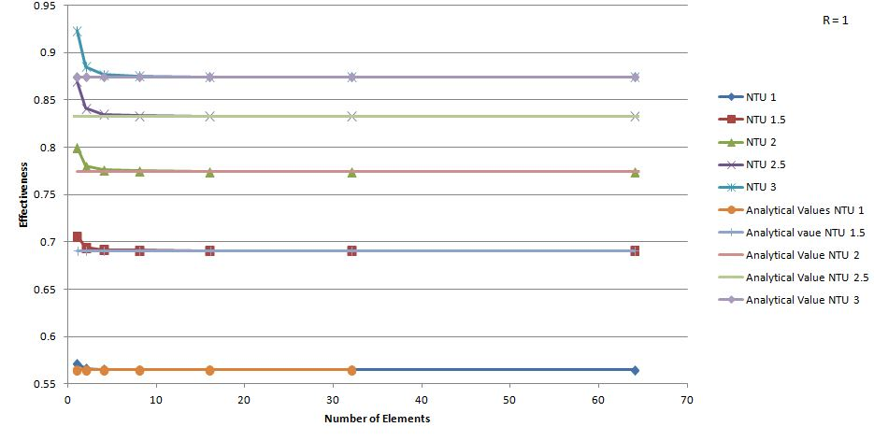Figure 9.3: Plot of Effectiveness vs Number of elements

**9.4 TWO FLUID COUNTER FLOW RESULTS – GALERKIN’S METHOD:**

**9.4.1 RESULTS TABLE:** The finite element method explained above was coded using MATLAB. The values of effectiveness for varying number of elements at different values of NTU were tabulated as follows:

|  |  |  |  |  |  |  |  |  |
| --- | --- | --- | --- | --- | --- | --- | --- | --- |
| **NTU** | **ANALYTICAL VALUE** | **1E** | **2E** | **4E** | **8E** | **16E** | **32E** | **64E** |
| **0.5** | 0.3623 | 0.3529 | 0.3619 | 0.3622 | 0.3622 | 0.3623 | 0.3623 | 0.3623 |
| **1** | 0.5647 | 0.5455 | 0.5632 | 0.5643 | 0.5646 | 0.5647 | 0.5647 | 0.5647 |
| **1.5** | 0.6908 | 0.6667 | 0.6879 | 0.6900 | 0.6906 | 0.6907 | 0.6908 | 0.6908 |
| **2** | 0.7746 | 0.7500 | 0.7706 | 0.7736 | 0.7743 | 0.7745 | 0.7746 | 0.7746 |
| **2.5** | 0.8328 | 0.8108 | 0.8282 | 0.8315 | 0.8325 | 0.8327 | 0.8328 | 0.8328 |
| **3** | 0.8744 | 0.8571 | 0.8696 | 0.8731 | 0.8741 | 0.8743 | 0.8744 | 0.8744 |

Table 9.4: Galerkin’s method two fluid counter flow

**9.4.2 PLOTS:** Plots of effectiveness vs number of elements was plotted at different values of NTU for counter flow

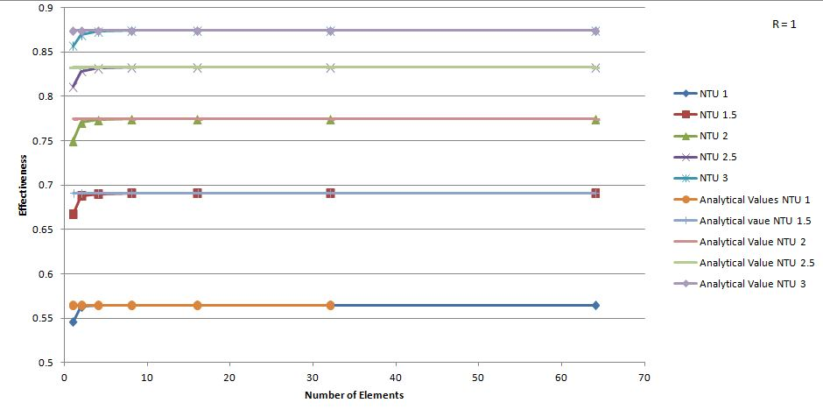Figure 9.4: Plot of Effectiveness vs Number of Elements

**9.5 CONVERGENCE TEST OF A THREE FLUID HEAT EXCHANGER FOR A UNIQUE CASE- RESULTS:**

**9.5.1 RESULT TABLE:** The finite element method explained above was coded using MATLAB. The values of effectiveness for varying number of elements at different values of NTU were tabulated as follows.

|  |  |  |  |  |  |  |  |  |
| --- | --- | --- | --- | --- | --- | --- | --- | --- |
| **NTU** | **ANALYTICAL VALUE** | **2E** | **4E** | **8E** | **16E** | **32E** | **64E** | **128E** |
| **0.5** | 0.3935 | 0.3920 | 0.3931 | 0.3934 | 0.3934 | 0.3935 | 0.3935 | 0.3935 |
| **1** | 0.6321 | 0.6269 | 0.6307 | 0.6318 | 0.6320 | 0.6321 | 0.6321 | 0.6321 |
| **1.5** | 0.7769 | 0.7692 | 0.7747 | 0.7763 | 0.7767 | 0.7768 | 0.7769 | 0.7769 |
| **2** | 0.8647 | 0.8571 | 0.8622 | 0.8640 | 0.8645 | 0.8646 | 0.8647 | 0.8647 |
| **2.5** | 0.9179 | 0.9123 | 0.9157 | 0.9173 | 0.9178 | 0.9179 | 0.9179 | 0.9179 |
| **3** | 0.9502 | 0.9474 | 0.9484 | 0.9497 | 0.9501 | 0.9502 | 0.9502 | 0.9502 |

Table 9.5: Unique Case for Three Fluid Heat Exchanger

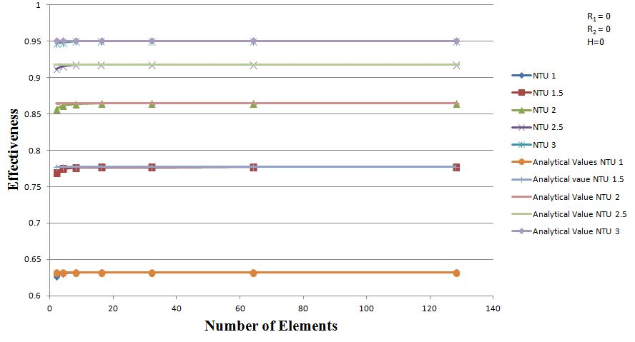**9.5.2 PLOTS:** Plots of effectiveness vs number of elements was plotted at different values of NTU. The analytical value is shown as a straight line in the plot.

Figure 9.5: Plot of Effectiveness vs Number of Elements

**9.6 THREE FLUID PARALLEL FLOW RESULTS – GALERKIN’S METHOD:**

**9.6.1 RESULTS TABLE:**

1. The finite element method explained above was coded using MATLAB. The values of effectiveness for varying number of elements at different values of NTU were tabulated as follows:
2. There is no exact formula for analytical effectiveness for a three fluid exchanger. Hence the repeating values of effectiveness above a minimum number of elements can be assumed to be the analytical effectiveness of the heat exchanger.

|  |  |  |  |  |  |  |  |  |  |
| --- | --- | --- | --- | --- | --- | --- | --- | --- | --- |
| **NTU** | **2E** | **8E** | **16E** | **32E** | **64E** | **128E** | **256E** | **512E** | **1024E** |
| **0.5** | 0.5268 | 0.5283 | 0.5281 | 0.528 | 0.5279 | 0.5279 | 0.5279 | 0.5279 | 0.5279 |
| **1** | 0.664 | 0.6577 | 0.6568 | 0.6563 | 0.6560 | 0.6559 | 0.6558 | 0.6558 | 0.6558 |
| **1.5** | 0.7088 | 0.6953 | 0.6935 | 0.6926 | 0.6921 | 0.6919 | 0.6918 | 0.6917 | 0.6917 |
| **2** | 0.7266 | 0.7113 | 0.7088 | 0.7075 | 0.7069 | 0.7066 | 0.7065 | 0.7064 | 0.7064 |
| **2.5** | 0.7353 | 0.7221 | 0.7190 | 0.7174 | 0.7167 | 0.7163 | 0.7161 | 0.7160 | 0.7160 |
| **3** | 0.7407 | 0.7316 | 0.7278 | 0.7260 | 0.7250 | 0.7246 | 0.7244 | 0.7243 | 0.7242 |

Table 9.6: Galerkin’s method three fluid parallel flow

**9.6.2 PLOTS**: Plots of effectiveness vs number of elements was plotted at different values of NTU

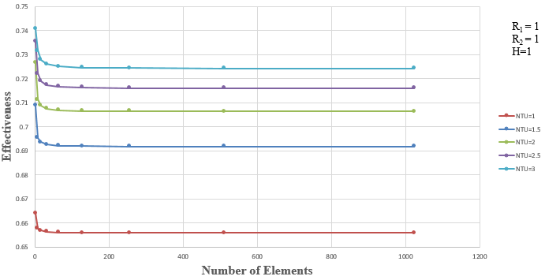

Figure 9.6: Plot of Effectiveness vs Number of Elements

**9.7 THREE FLUID PARALLEL FLOW RESULTS- SUBDOMAIN COLLOCATION METHOD:**

**9.7.1 RESULTS TABLE:**

1. The finite element method explained above was coded using MATLAB. The values of effectiveness for varying number of elements at different values of NTU were tabulated as follows:
2. There is no exact formula for analytical effectiveness for a three fluid exchanger. Hence the repeating values of effectiveness above a minimum number of elements can be assumed to be the analytical effectiveness of the heat exchanger.

|  |  |  |  |  |  |  |  |
| --- | --- | --- | --- | --- | --- | --- | --- |
| **NTU** | **2E** | **4E** | **8E** | **16E** | **32E** | **64E** | **128E** |
| **0.5** | 0.5289 | 0.5206 | 0.5186 | 0.5181 | 0.5180 | 0.5179 | 0.5179 |
| **1.0** | 0.6531 | 0.6382 | 0.6346 | 0.6338 | 0.6335 | 0.6335 | 0.6335 |
| **1.5** | 0.6644 | 0.6626 | 0.6601 | 0.6595 | 0.6593 | 0.6593 | 0.6593 |
| **2.0** | 0.6400 | 0.6664 | 0.6655 | 0.6651 | 0.6650 | 0.6650 | 0.6650 |
| **2.5** | 0.6049 | 0.6667 | 0.6663 | 0.6663 | 0.6663 | 0.6663 | 0.6663 |
| **3.0** | 0.5680 | 0.6667 | 0.6666 | 0.6666 | 0.6666 | 0.6666 | 0.6666 |

Table 9.7: Sub-Domain Collocation Method Three Fluid Parallel Flow

* + 1. **PLOTS:** Plots of effectiveness vs number of elements was plotted at different values of NTU

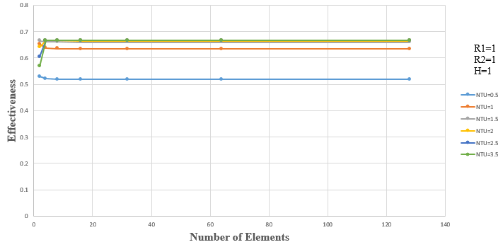

Figure 9.7: Plot of Effectiveness vs Number of Elements

**9.8 THREE FLUID COUNTER FLOW RESULTS- GALERKIN’S METHOD:**

* + 1. **RESULTS TABLE:**

1. The finite element method explained above was coded using MATLAB. The values of effectiveness for varying number of elements at different values of NTU were tabulated as follows:
2. There is no exact formula for analytical effectiveness for a three fluid exchanger. Hence the repeating values of effectiveness above a minimum number of elements can be assumed to be the analytical effectiveness of the heat exchanger.

|  |  |  |  |  |  |  |  |
| --- | --- | --- | --- | --- | --- | --- | --- |
| **NTU** | **2E** | **4E** | **8E** | **16E** | **32E** | **64E** | **128E** |
| **0.5** | 0.5682 | 0.5703 | 0.5709 | 0.5710 | 0.5710 | 0.5711 | 0.5711 |
| **1** | 0.7778 | 0.7831 | 0.7846 | 0.7849 | 0.7850 | 0.7851 | 0.7851 |
| **1.5** | 0.8763 | 0.8829 | 0.8848 | 0.8853 | 0.8854 | 0.8855 | 0.8855 |
| **2** | 0.9286 | 0.9345 | 0.9365 | 0.9371 | 0.9372 | 0.9372 | 0.9372 |
| **2.5** | 0.9583 | 0.9627 | 0.9645 | 0.9649 | 0.9651 | 0.9651 | 0.9651 |
| **3** | 0.9759 | 0.9785 | 0.9799 | 0.9803 | 0.9804 | 0.9805 | 0.9805 |

Table 9.8: Galerkin’s Method Three Fluid Counter Flow

* + 1. **PLOTS:** Plots of effectiveness vs number of elements was plotted at different values of NTU 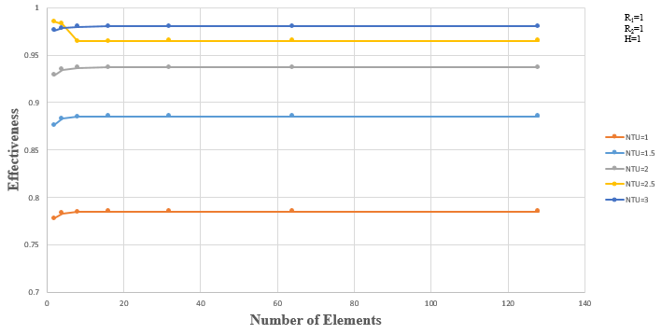

Figure 9.8: Plot of Effectiveness vs Number of Elements

**9.9 THREE FLUID COUNTER FLOW RESULTS- SUBDOMAIN COLLOCATION METHOD:**

**9.9.1 RESULTS TABLE:**

1. The finite element method explained above was coded using MATLAB. The values of effectiveness for varying number of elements at different values of NTU were tabulated as follows:
2. There is no exact formula for analytical effectiveness for a three fluid exchanger. Hence the repeating values of effectiveness above a minimum number of elements can be assumed to be the analytical effectiveness of the heat exchanger.

|  |  |  |  |  |  |  |  |  |
| --- | --- | --- | --- | --- | --- | --- | --- | --- |
| **NTU** | **2E** | **4E** | **8E** | **16E** | **32E** | **64E** | **128E** | **256E** |
| **0.5** | 0.7191 | 0.7037 | 0.7001 | 0.6992 | 0.6990 | 0.6989 | 0.6989 | 0.6989 |
| **1.0** | 0.9697 | 0.9373 | 0.9296 | 0.9278 | 0.9273 | 0.9272 | 0.9271 | 0.9271 |
| **1.5** | 0.9948 | 0.9908 | 0.9854 | 0.9839 | 0.9836 | 0.9835 | 0.9834 | 0.9834 |
| **2.0** | 0.9412 | 0.9994 | 0.9973 | 0.9965 | 0.9964 | 0.9963 | 0.9963 | 0.9963 |
| **2.5** | 0.8672 | 1.0000 | 0.9996 | 0.9993 | 0.9992 | 0.9992 | 0.9992 | 0.9992 |
| **3.0** | 0.7934 | 1.0000 | 0.9999 | 0.9999 | 0.9998 | 0.9998 | 0.9998 | 0.9998 |

Table 9.9: Sub-Domain Collocation Method Three Fluid Counter Flow

* + 1. **PLOTS:** Plots of effectiveness vs number of elements was plotted at different values of NTU

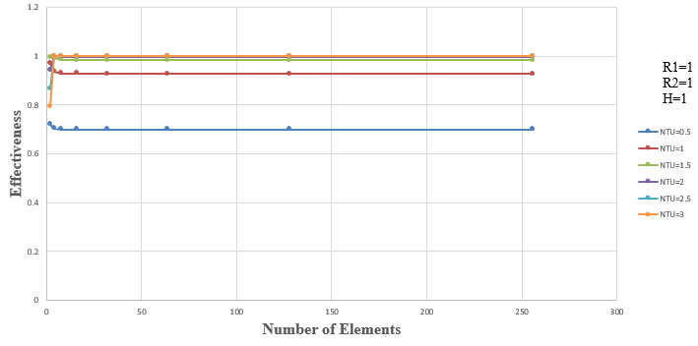

Figure 9.9: Plot of Effectiveness vs Number of Elements

**CONCLUSION AND FUTURE SCOPE**

From the project conducted, the following conclusions were drawn.

1. In literature survey, we found that the Sub-Domain collocation method was more accurate than Galerkin’s method. We were able to provide enough information to support the above observation.
2. Finite element methods can be used to analyze heat exchangers. The process is cumbersome but when coded in MATLAB, the solution is simplified.
3. The sub-domain collocation method and Galerkin’s method are both efficient method for analysis. But the convergence of solution is observed at lesser number of elements in Sub-domain collocation method as compared to Galerkin’s method.
4. For same operating conditions, the effectiveness of three-fluid heat exchanger was more than that for a two fluid heat exchanger.
5. There is no exact formula for analytical effectiveness of three fluid heat exchangers as the heat exchanges are complex to analyze.
6. The complexity of solution for three-fluid heat exchanger is higher than two-fluid heat exchanger. Hence more number of elements was required to observe convergence of solution.
7. From the case study, we can confirm the MATLAB code for three fluid is satisfactory.
8. Analytical methods cannot be used to analyse three or higher number of fluids heat exchanger. This finite element formulation can be used to analyse such problems.
9. This method can be extended to n-fluid heat exchangers.
10. The current study is for steady state conditions. It can be extended to transient conditions.

**REFERENCES**

1. Holman J P, “Heat Transfer”, 10th edition, McGraw-Hill, New York, 2010.
2. F. P. Incropera, D. P. DeWitt, T. L. Bergman, and A. S. Lavine, “Fundamentals of Heat and Mass Transfer”, 6th edition, Wiley Publication, 2007.
3. J N Reddy, “An Introduction to Finite Element Method”, 3rd edition, McGraw-Hill, New York, 2005.
4. A.J.M. Ferreira, “MATLAB Codes for finite element analysis”.
5. Sekulic, D.P. and Shah, R.K. (1995), “Thermal design theory of three-fluid heat exchanger”, Advances in Heat Transfer, Vol. 26, pp. 219-328.
6. Shrivastava, D. and Ameel, T.A. (2004a), “Three-fluid heat exchangers with three thermal communications. Part A: general mathematical model”, Int. J. Heat Mass Transfer, Vol. 47, pp. 3855-3865.
7. K N Seetharamu, “Finite Element Method for Heat Exchangers”, Chapter 11.
8. Nawaf H. Saeid and K.N. Seetharamu, “Finite Element Analysis for Co-current and Counter-current Parallel Flow Three-fluid Heat Exchanger”, School of Mechanical Engineering, University Sains Malaysia, Engineering Campus 14300, Nibong Tebal, Pulau Pinang, Malaysia, 2005.
9. Leszek Malinowski and Jian Hua Chen, "Analytical Solutions For The Equations For The Transient Temperature Field In The Three Fluid Parallel Channel Heat Exchanger With Three Thermal Communications", International Journal of Heat and Mass Transfer, Vol. 96, pp. 164- 170.
10. Ramesh K Sharma and Dusan P Sekulic, “Fundamentals of Heat Exchanger Design”, John Wiley & Sons, Inc., Hoboken, New Jersey, 2003.
11. Shrivastava, D and Ameel, T.A. (2004b), “Three-fluid heat exchangers with three thermal communications. Part B: effectiveness evaluation”, Int. J. Heat Mass Transfer, Vol. 47, pp. 3867-3875.
12. J Wolf, General solutions of the equations of the parallel flow multi-channel heat exchangers, Int. J. Heat Mass Transfer 7 (1964) 901.
13. Sekulic D P, “A compact solution of the parallel flow three-fluid heat exchanger problem”, 1994.
14. Seetharamu, K.N, Quadir, G A, Zainal Z A and Krishnan G.M, “FEM analysis of multi-fluid heat exchangers”, Int. J. Num. Meth. Heat Fluid Flow, Vol. 14, pp. 242-255, 2004.

**APPENDIX**

**MATLAB CODES**

**THREE FLUID PARALLEL FLOW (ONLY THE MAIN PART)**

% heat.m

N= input ('Number of elements N='); %enter the number of elements

NTU = 0.5; %

R1 = 1; %

R2 = 1; %

Rmin = min (1, (R1^-1 + R2^-1)); %

h = 1; %

NTUe =NTU/N;

n=6+ (3*(N-1)); % Number of variables

%

%let the variables be

%

a= NTUe/3;

b= NTUe*R1/3;

c= a*h;

d= a*R2*h;

%

KK = zeros (n); % Initialize global stiffness matrix to zero

F= zeros (n, 1); % Initialize global force vector to zero

%

%Loading

%

F (1, 1) =1; %BC of 1st node is given 1

%

%Elemental stiffness matrix

%

k= [-0.5+a+c -a -c 0.5+a/2+c/2 -a/2 -c/2; ...

-b -0.5+b 0 -b/2 0.5+b/2 0;...

-d 0 -0.5+d -d/2 0 0.5+d/2;...

-0.5+a/2+c/2 -a/2 -c/2 0.5+a+c -a -c/2;...

-b/2 -0.5+b/2 0 -b 0.5+b 0;...

-d/2 0 -0.5+d/2 -d 0 0.5+d];

%

%Global Stiffness Matrix Assembly

%2

for ii=1:N

KK (3*ii-2:3*(ii+1), 3*ii-2:3*(ii+1)) =...

KK (3*ii-2:3*(ii+1), 3*ii-2:3*(ii+1)) +k;

end

%

%Imposing Boundary Condition

KK (1, : ) =0;

KK (1, 1) =1;

KK (2, : ) =0;

KK (2, 2) =1;

KK (3, : ) =0;

KK (3, 3) =1;

%

%%%%%%%%%%%%% End of Assembly of Matrices %%%%%%%%%%%%%%%%%

%

%Solution for the unknown O (Temp. difference) values

%

O = KK\F;

%

Oho=O ((n-2), 1);

Ohi=O (1, 1);

Oc1i=O (2, 1);

Oc2i=O (3, 1);

%

%Effectiveness

%

E= (Ohi-Oho) / (min (1, (R1^-1 + R2^-1))*(Ohi- min (Oc1i, Oc2i)));

**THREE FLUID COUNTER FLOW (ONLY THE MAIN PART)**

% heat.m

N = input ('Number of elements N='); %enter the number of elements

NTU = 0.5; %

R1 = 1; %

R2 = 1; %

Rmin = min (1, (R1^-1 + R2^-1)); %

h = 1; %

NTUe =NTU/N;

n=6+ (3*(N-1)); % Number of variables

%

% Let the variables be

%

a=NTUe/3;

b=NTUe*R1/3;

c=a*h;

d=a*R2*h;

%

KK =zeros (n); % Initialize global stiffness matrix to zero

F=zeros (n, 1); % Initialize global force vector to zero

%

%Loading

%

F (1, 1) =1; %BC of 1st node is given 1

%

%Elemental stiffness matrix

%

k= [-0.5+a+c -a -c 0.5+a/2+c/2 -a/2 -c/2;...

b -0.5-b 0 b/2 0.5-b/2 0;...

d 0 -0.5-d d/2 0 0.5-d/2;...

-0.5+a/2+c/2 -a/2 -c/2 0.5+a+c -a -c/2;...

b/2 -0.5-b/2 0 b 0.5-b 0;...

d/2 0 -0.5-d/2 d 0 0.5-d];

%

%Global Stiffness Matrix Assembly

%2

for ii=1:N

KK (3*ii-2:3*(ii+1), 3*ii-2:3*(ii+1)) =...

KK (3*ii-2:3*(ii+1), 3*ii-2:3*(ii+1)) +k;

end

%

%Imposing Boundary Condition

KK (1, : ) =0;

KK (1, 1) =1;

KK (2, : ) =0;

KK (2, n-1) =1;

KK (3, : ) =0;

KK (3, n) =1;

%

%%%%%%%%%%%%% End of Assembly of Matrices %%%%%%%%%%%%%%%%%

%

%Solution for the unknown O (Temp. difference) values

%

O = KK\F;

%

Oho=O ((n-2), 1);

Ohi=O (1, 1);

Oc1i=O (2, 1);

Oc2i=O (3, 1);

%

%Effectiveness

%

E= 1-Oho;

%